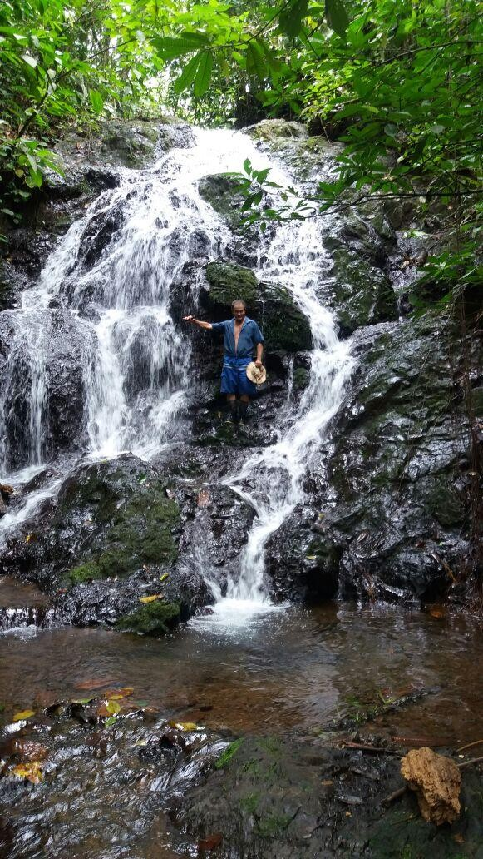
Proyecto Bosque Vivo OSA: PSA en Biodiversidad
Dirección de Desarrollo y Comercialización de Servicios Ambientales
Financiadores (Mayo 2018)

Toyota Rent a Car ANC Car Rental FIFCO
Green Motion International PROQUINAL Costa Rica
Cooper Visión Manufacturing Costa Rica SRL
Go Green Travel Group CR S.A. Autos Corcobado
Ruscosta S.A. Condominio Vertical Horizontal
Comercial Terramall
IZI Card
Align Technology de Costa Rica SRL
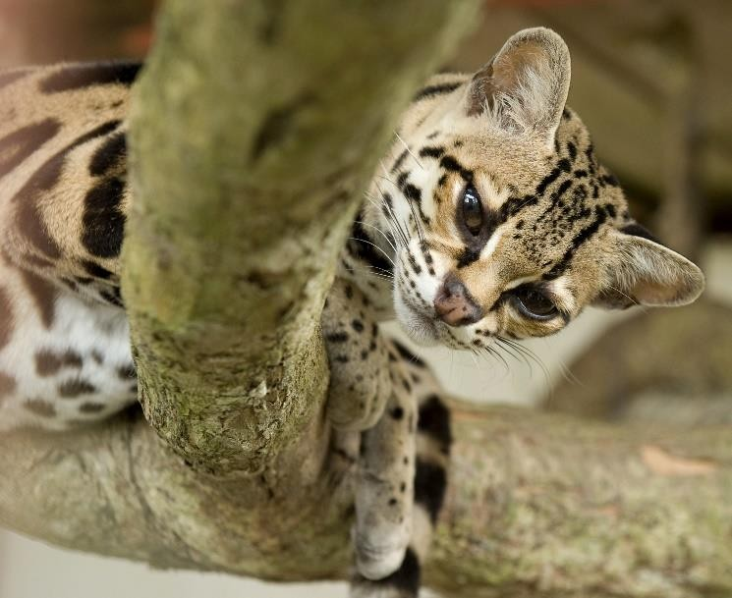

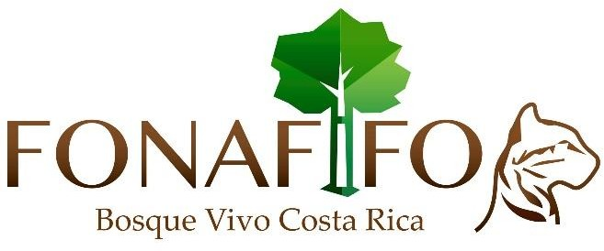
Visite:
Facebook Bosque Vivo Costa Rica

Contáctenos: mercadeo@fonafifo.go.cr TEL: (506) 2545-3535

